Priyadarshini transfer Description - **1543-PriyadarVIIIA**

Rohit transfer Description - **1775-Rohit R(VI-B)**

**28Jul2016: School fees paid through HDFC bank:**

**1543 – PRIYADARSHINI RADHAKRISHNAN - VIII A**

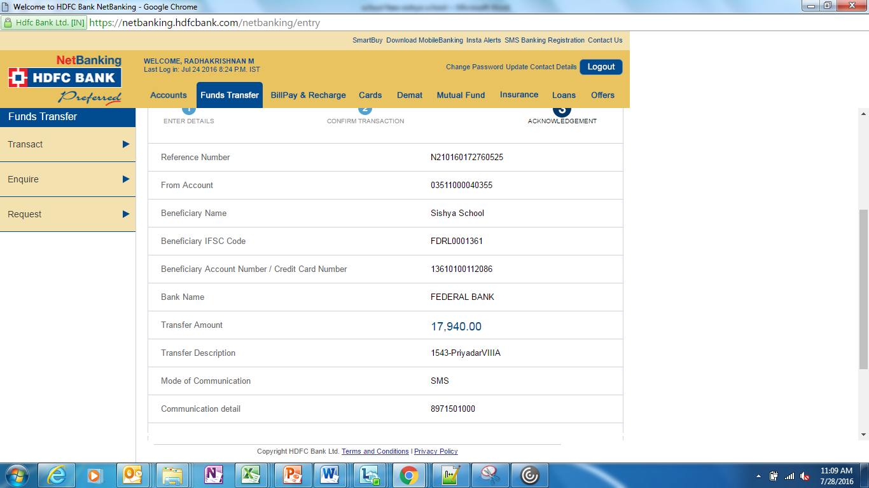

**1775 – ROHIT RADHAKRISHNAN - VI B**

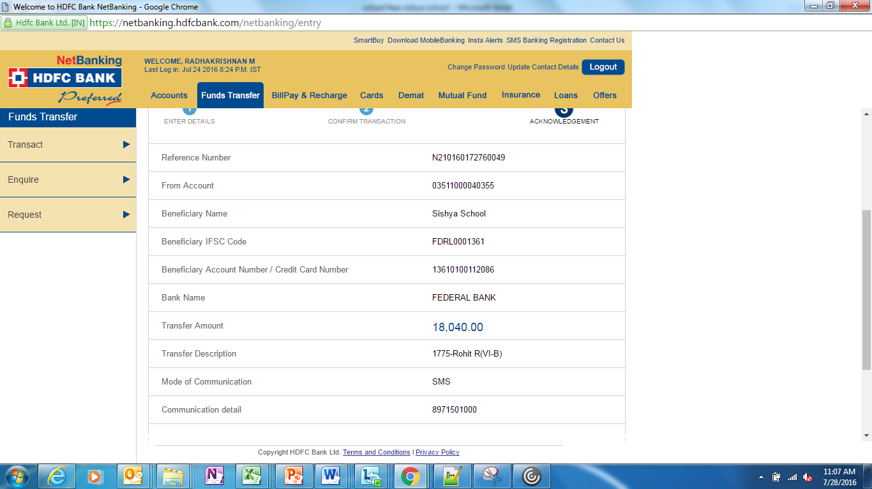

16May2016: School Fees paid through HDFC bank:

Priyadarshini transfer Description - **1543-PriyadarVIIIA**

Rohit transfer Description - **1775-Rohit R(VI-B)**

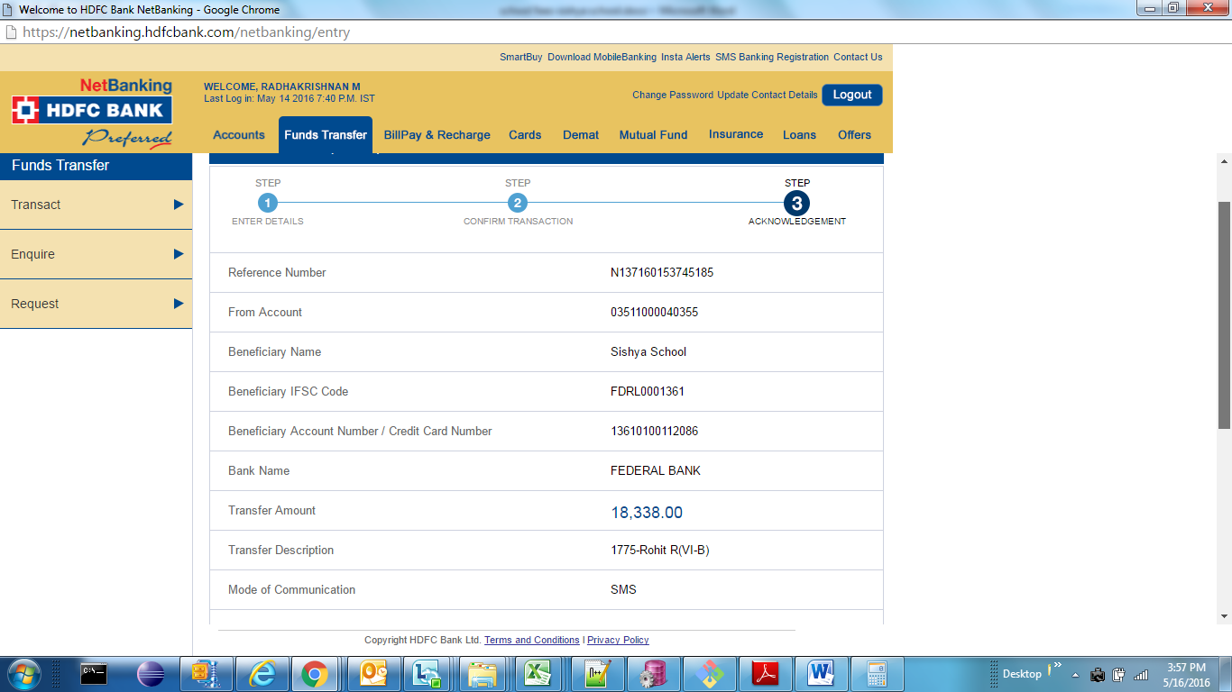

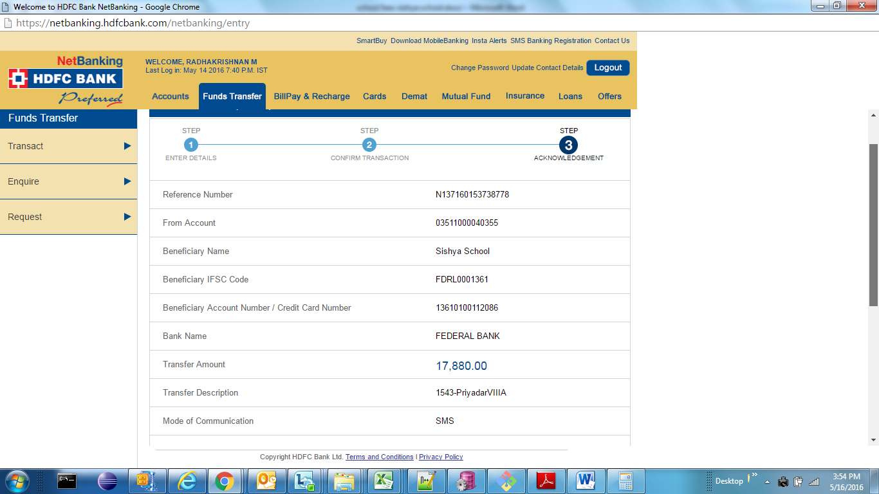

1775-Rohit R/ V-A (Description for ROhit)

23Mar2016:

School fees for the Priyadarshini R(Admission no: 1543 – VII-A) – 315/

School fees for the Rohit R(Admission no: 1775 – V -A) – 645/

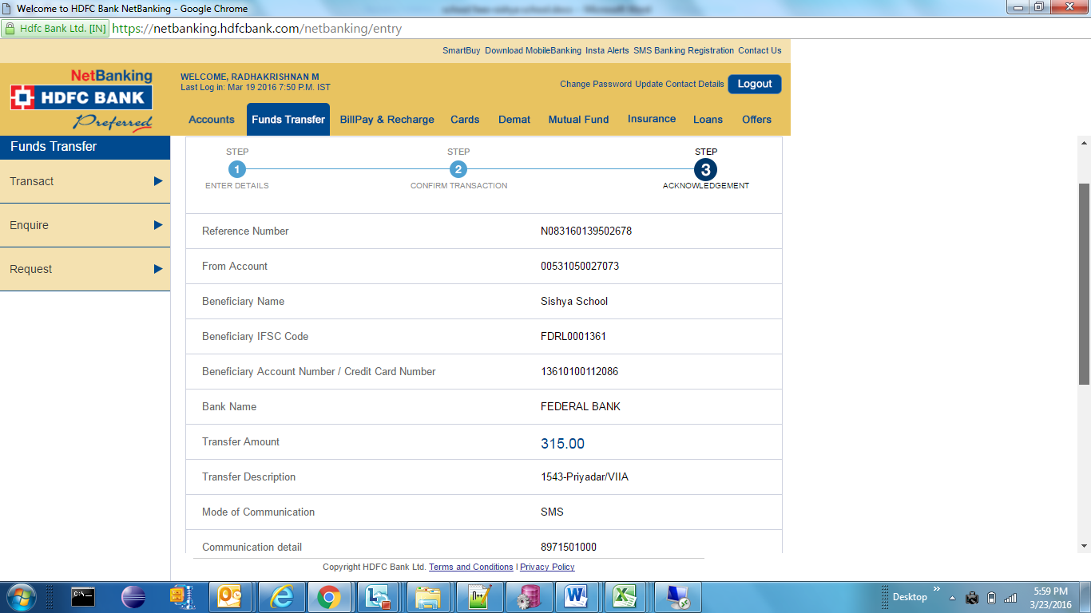

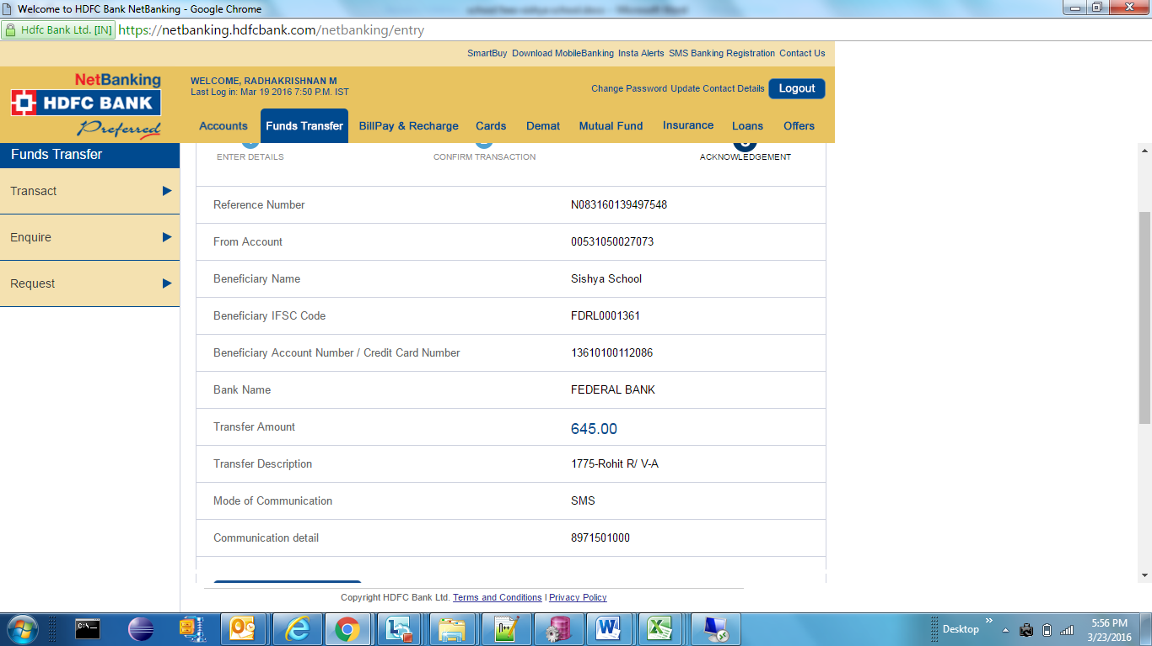

28Jan2016:

School fees for the Priyadarshini R(Admission no: 1543 – VII-A) – 13935/

School fees for the Rohit R(Admission no: 1775 – V -A) – 14635/

